"Arduino Based Home Automation Project via Bluetooth”

A PROJECT REPORT

Submitted by
GROUP NAME: DOMINATORS

BONU PAVAN KUMAR(190101120054)
POTNURU VARUN(190101120046)

Guided by
DEBASIS SAHU
HEAD OF DEPARTMENT CSE
CENTURION UNIVERSITY OF TECHNOLOGY AND MANAGEMENT

in partial fulfill ment for the award of the degree of

BACHELOR OF TECHNOLOGY
in
COMPUTER SCIENCE ENGINEERING


DEPARTMENT OF CSE

CENTURION UNIVERSITY OF TECHNOLOGY AND MANAGEMENT
PARALAKHEMUNDI, ODISHA

DECLARATION

We hereby declare that the project entitled “ ARDUINO BASED HOME AUTOMATION PROJECT VIA BLUETOOTH” is a record of our original work done under" HEAD OF DEPARTMENT", DEBASIS SAHU CENTURION UNIVERSITY OF TECHNOLOGY & MANAGEMENT, Paralakhemundi. Throughout this Project wherever contributions of others are involved every effort has been made to acknowledge this clearly with due reference to literature. This project work is being submitted in partial fulfilment of the requirements for the degree of Bachelor of Technology in computer science Engineering at CENTURION UNIVERSITY OF TECHNOLOGY & MANAGEMENT , Paralakhemundi for the academic session 2019-2023

CENTURION UNIVERSITY OF TECHNOLOGY AND MANAGEMENT
PARALAKHEMUNDI, ODISHA
Department of computer science Engineering



CERTIFICATE

This is to certify that the project report titled as “ARDUINO BASED HOME AUTOMATION PROJECT VIA BLUETOOTH" being submitted by BONU PAVAN KUMAR,POTUNURU VARUN from B.Tech 4th semester of computer science engineering is a record bonafide work carried out by us. The results embodied in this report have not been submitted to any other University for the award of any degree.

Signature of the Guide Signature of the H.O.D

Signature of the External Signature of the principal

ABSTRACT

We are living in 21 century where automation of any form I.e home or industrial pays an important role in human life. When t comes to industrial automation, the concept is applied to large machines or robots which help in increasing the efficiency in terms of production, energy and time. Home automation on the other hand involves automating the household environment. This is possible because of the smartphones and internet that we are widely using Home automation can be again divided in to just controlling the appliances using a smartphone from a remote location and another type filled with sensors and actuators which controls the lighting. temperature, door locks, gadgets, electrical appliances etc. using a "Smart" system
The main objective of this project is to develop a home automation system using an Arduino board with Bluetooth being remotely controlled by any Android OS smart phone. As technology is advancing so houses are getting smarter. Modem houses are gradually shifting from conventional switches to centralized control system, involving remote controlled switches. Presently, conventional wall switches located in different parts of the house makes it difficult for the user to go near them to operate. Even more becomes more difficult for the elderly or physically handicapped people to do so. Remote controlled home automation system provides a most modern solution with smart phones.In order to achieve this, a Bluetooth module is interfaced to the Arduino board at the receiver end while on the transmitter end, a GUI application on the cell phone sends ON/OFF commands to the receiver where loads are connected. By touching the specified location on the GUI, the loads can be turned ON/OFF remotely through this technology .

CHAPTER-1
INTRODUCTION AND FLOW CHART

1.1Introduction:
Nowadays, we have remote controls for or television sets and other electronic systems, which have made our lives real easy. Have you ever wondered about home automation which would give the facility of controlling tube lights, fans and other electrical appliances at home using a remote control? Off-course, Yes! Bu. are the available options cost-effective? If the answer is No, we have found a solution to i. We have come up with a new system called Arduino based home automation using Bluetooth This system is super-cost effective and can give the user, the ability to control any electronic device without even spending for a remote control. This project helps the user to control all the electronic devices sing his/her smartphone. Time is a very valuable thing Everybody wants to save time as much as they can. New technologies are being introduced to save our time. To sae people's time we are introducing Home Automation system using Bluetooth With the help of this system you can control your home appliances from your mobile phone. You can turn on/off your home appliances within the range of Bluetooth.

II. System Block Diagram
To develop a Bluetooth based home automation system with Arduino UNO Board and an Android application.Remote controlled home automation system provides a simpler solution with Android application technology.Remote operation is achieved by any smartphone/Tablet etc., with Android OS, upon a GUI(Graphical User Interface) based touch screen operation.

1.2 Block Diagram of Software Implementation:

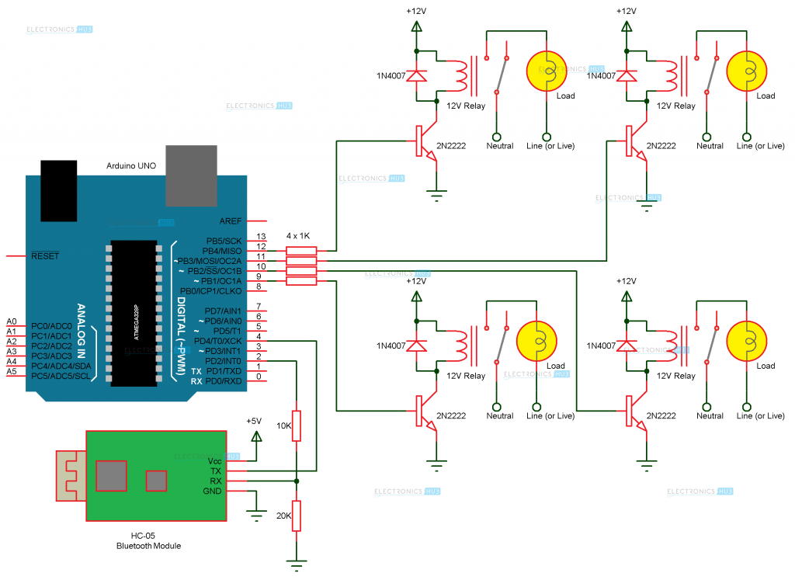

CHAPTER 2
PROGRAMMING CODE

#include <SoftwareSerial.h>
const int rxPin = 4;
const int txPin = 2;

SoftwareSerial mySerial(rxPin, txPin);

const int Loads[] = {9, 10, 11, 12};

int state = 0;
int flag = 0;

void setup()
{
for (int i=0;i<4;i++)
{
pinMode(Loads[i], OUTPUT);
}
mySerial.begin(9600);
for (int i=0;i<4;i++)
{
digitalWrite(Loads[i], LOW);
}

}

void loop()
{

if(mySerial.available() > 0)
{
state = mySerial.read();
flag=0;
}

switch(state)
{
case '0':digitalWrite(Loads[0], HIGH);
flag=1;
break;
case '1':digitalWrite(Loads[0], LOW);
flag=1;
break;
case '2':digitalWrite(Loads[1], HIGH);
flag=1;
break;
case '3':digitalWrite(Loads[1], LOW);
flag=1;
break;
case '4':digitalWrite(Loads[2], HIGH);
flag=1;
break;
case '5':digitalWrite(Loads[2], LOW);
flag=1;
break;
case '6':digitalWrite(Loads[3], HIGH);
flag=1;
break;
case '7':digitalWrite(Loads[3], LOW);
flag=1;
break;
case '8':digitalWrite(Loads[0], LOW);
digitalWrite(Loads[1], LOW);
digitalWrite(Loads[2], LOW);
digitalWrite(Loads[3], LOW);
flag=1;
break;
}
}

CHAPTER 3
HARDWARE DESCRIPTION
- 3.1 Hardware Requirements:COST ESTIMATION
- Arduino uno = 420
- Hc-05 Bluetooth module = 350
- 10 KΩ Resistor = 120
- 20 KΩ Resistor = 140
- 1 KΩ Resistor X 4 = 100
- Bread board = 200
- connecting wires = 120
Total 1450
3.2 HARDWARE DESCRIPTION

3.3ARDUINO:
Fig3.3 Arduino Uno
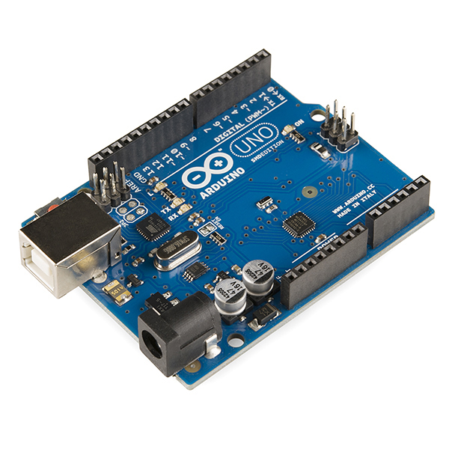

The Arduino uno is a micro controller board based on the ATmega328. It has 20 digital input/output pins (of which 6 can be used as PWM outputs and 6 can be used as analog inputs), a 16 MHz resonator, a USB connection, a power jack, an in-circuit system programming (ICSP) header, and a reset button.
3.4 Bluetooth Module:
The Bluetooth Module used in this project is HC- 05. As seen in the image below, this Bluetooth module has 4 – pins for VCC (5V), ground, TX and RX.
This Bluetooth can be used with Bluetooth enabled phone (or tablet or laptop) and the range of this module is approximately 10 meters.

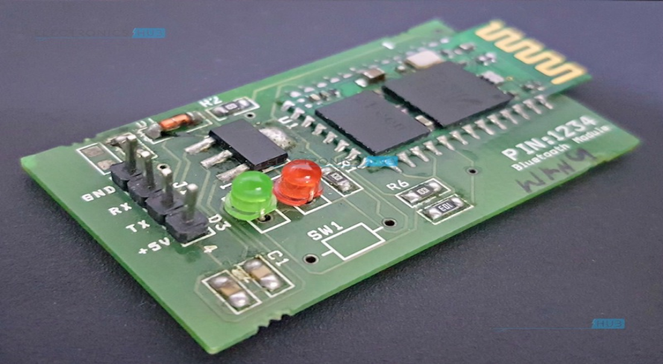

3.5. Channel Relay Board:
smoke detector is a device that senses smoke, typically as an indicator of fire. Commercial smoke detectors issue a signal to a fire alarm control panel as part of a fire alarm system, while household .
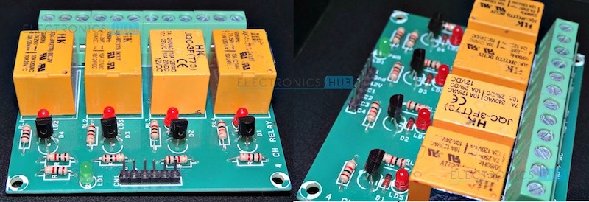

3.6 Relay:
Relay is basically an electromagnetic switch which can be turn on and off by an applying the voltage across its contacts.In this project used a 12V 4-channel relay
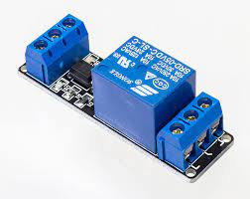

3.7 Circuit Design:
- The circuit design of Home Automation based on Arduino and Bluetooth is very simple and is explained below.

- The Bluetooth module has 4 – pins: VCC, TX, RX and GND. VCC and GND are connected to 5V and ground from Arduino UNO. The Bluetooth module works on 3.3V and it has an on board 5V to 3.3V regulator.
- The TX and RX pins of the Bluetooth module must be connected to RX and TX pins of the Arduino. In Arduino UNO, we are defining pins 2 and 4 as RX and TX using software. Hence, TX of Bluetooth is connected to pin 4 of Arduino.

- But when connecting RX of Bluetooth to TX of Arduino (or any microcontroller as a matter of fact), we need to be careful as the pin can tolerate only 3.3V. But the voltage from TX or Arduino will be 5V.
- So, a voltage divider network consisting of 10K and 20K resistors are used to reduce the voltage to 3.3V approximately.

- Note: Any combination of resistors can be used to bring down the voltage to approximately 3.3V.
- The next step is to connect the digital I/O pins of the Arduino to input of the relay board.

- More detailed information about Arduino Bluetooth Interface and Arduino Relay Control.

3.8 Working Process:

- A simple home automation project using Arduino UNO, Bluetooth module and a smartphone. The aim of this project is to control different home appliances using a smartphone. The working of the project is explained here.

- When the power is turned on, the connection LED on the Bluetooth module starts blinking. We need to start the “Bluetooth Controller” app in our smartphone and get connected to the Bluetooth module. If the pairing is successful, the LED becomes stable.

- Now, in the app, we need to set different keys for different loads and their corresponding value that must be transmitted when that key is pressed. The following image shows a set of keys to control 4 loads and an additional key to turn off all the loads.
- Then we are ready to control the loads. When a key is pressed in the smartphone, the Bluetooth module receives the corresponding data and intern transmits that data to Arduino.
- For example, if we press “LOAD 2 ON”, then the data received by the Bluetooth module is “2”.This data i.e. “2” is transmitted to Arduino. Arduino then compares the received data with the data written in the sketch and accordingly turns on the load 2. The similar action can be applicable to other keys and loads.
- Using this type of connection, we can control i.e. turn on or off different home electrical appliances using our smartphones.
- 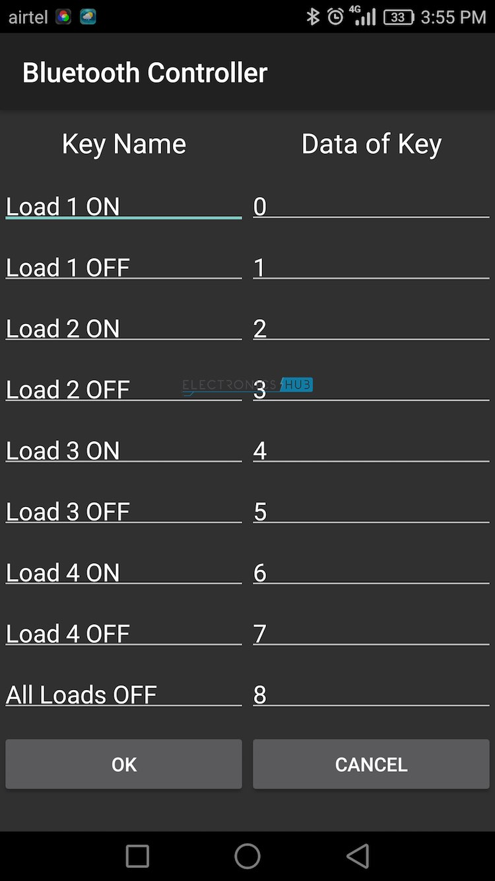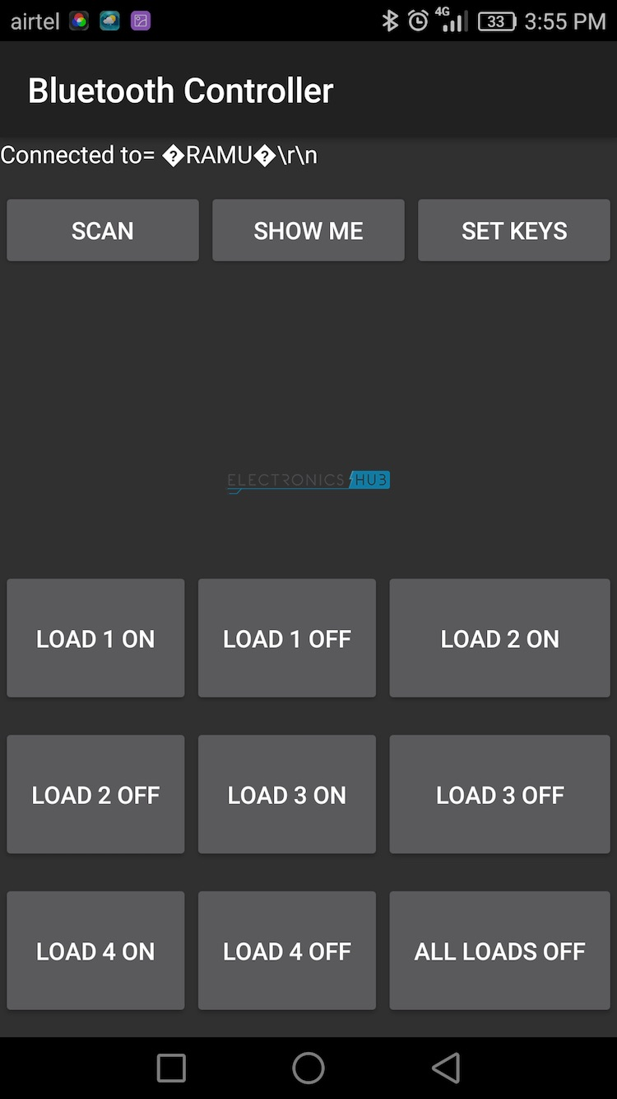

3.9 app download play store steps:
Step 1: Download the Bluetooth Controller app from google play store.

Step 2: Once the Bluetooth in Android phone is turned ON and the app is started, the following screen will be opened.

Step 3: Here, we can set the data to be transmitted when a particular key is pressed by selecting “SET KEYS” option.

Step 4: In order to connect the Bluetooth module we need to press “SCAN” and list of available Bluetooth device select your Bluetooth device. “Connected” is appeared on the top left of the screen

Step 5: Once the setup is done, we are ready to transmit the data to Arduino. When Light1 ON is press light1 will glow and if Light1 OFF is pressed Light1 will stop glowing. Same to Light2. If we need turn OFF all lights we need to press All Loads OFF.

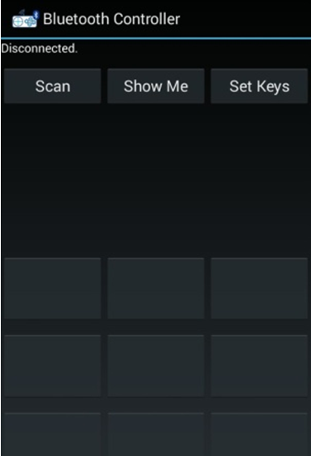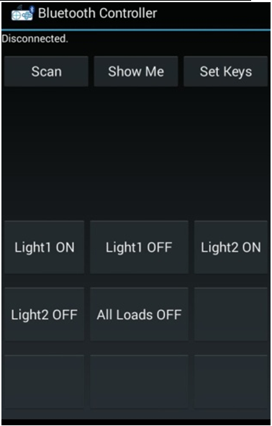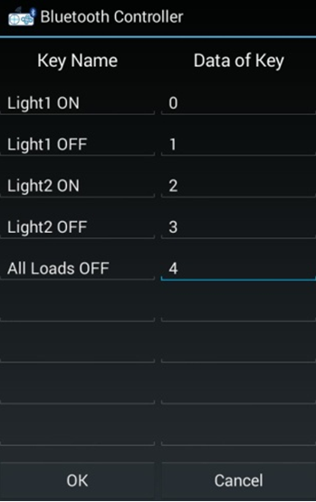
CHAPTER-4
SIMULATION RESULTS
4.1

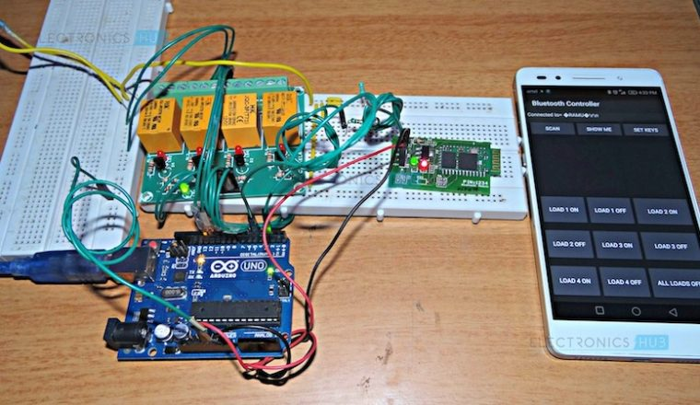

4.2 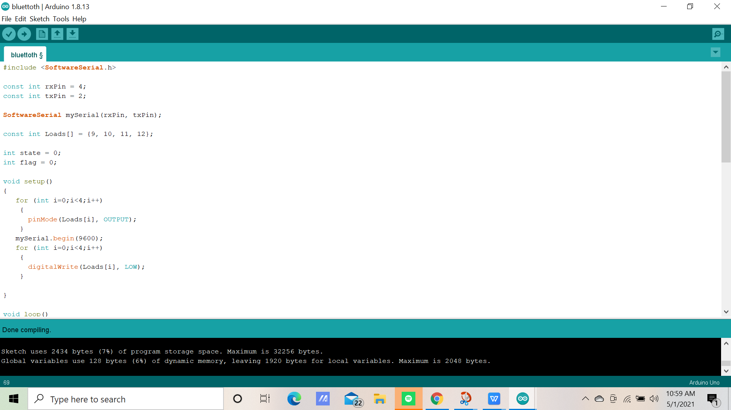

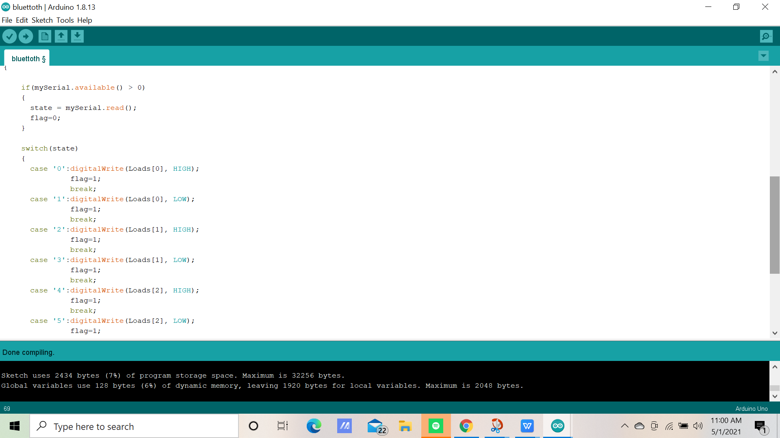

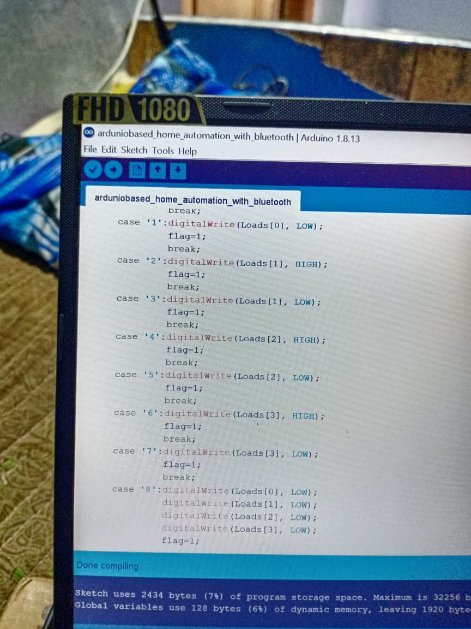
4.4 Applications:
- Using this project, we can turn on or off appliances remotely i.e. using a phone or tablet.
- The project can be further expanded to a smart home automation system by including some sensors like light sensors, temperature sensors, safety sensors etc. and automatically adjust different parameters like room lighting, air conditioning (room temperature), door locks etc. and transmit the information to our phone.
- Additionally, we can connect to internet and control the home from remote location over internet and also monitor the safety

- 4.5 Limitations:
- The system needs a continuous power supply to be practical or else we might not be able to control the appliances.
- Hence, best way to design the system efficiently would be to implement both the automated control and manual control through switches at a time.

CHAPTER-5
RESULT AND CONCLUSIONS
5.1 ADVANTAGES

- It is a robust and easy to use system.
- There is no need for extra training of that person who isusing it.
- All the control would be in your hands by using this homeautomation system.
- This project can provide the facility of monitoring all theappliances with in the communication range through Bluetooth.
- The schematic of Arduino is open source, for the future enhancement of the project board can be extended to add more hardware features.
- provides security
- smart home technology.
- it will save your energy and money.
- convenience and comfort.

- 5.2 Disadvantages:
- Bluetooth is used in this home automation system,which have a range of 10 to 20 meters so the control cannot be achieved from outside thisrange.
- Application is connected after disconnect of theBluetooth.
- When the new users want to connect, first download application software and then configuration must be done.
- High power consumption because of bluetooth connectivity.
- Circuit complexity increases as number of devices increase.
- Only works for limited range or short distance with in 5-10m surroundings.

5.3 Future Work:
- Memory can be used to store the appliance
- status during power failure.
- Appliance scheduler/timer can be implemented using RTC (Real Time Clock)
- Can be changes to an IoT device using WiFi connectivity
- This setup can further be developed into iot project by using etherenet ardunio and a wifi module.

5.4 References:
- www.atmel.com
- www.arduino.org
- www.beyondlogic.org
- www.wikipedia.org
- www.elementzonline.com
- www.elementztechblog.wordpress.com

5.5 Conclusion :
The home automation system has been experimentally proven to work satisfactorily by connecting sample appliances to it and the appliances were successfully controlled from a wireless mobile device. We learned many skills such as soldering, wiring the circuit and other tools that we use for this project and was able to work together as a team during this project. The Bluetooth client was successfully tested on a multitude of different mobile phones from different manufacturers, thus proving its portability and wide compatibility. Thus a low-cost home automation system was successfully designed, implemented and tested.
THANK YOU SIR - DOMINATORS - GROUP

Bonu pavanKumar-(190101120054) -Cse
Potnuru Varun-(190101120046)- cse

